CBOE
Test Plan
PITS 43986
SEDL 9119
A change was made so that the acronym does not become disabled after all the users located under that acronym are disabled. For the following test cases you will need to find a acronym that uses multiple logins like user ABL-CBOE shown below

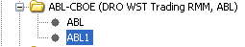

Test Case 1: Disable all users under Acronym
- Login to SA GUI.
- Select user ABL and ‘Disable’ this user.
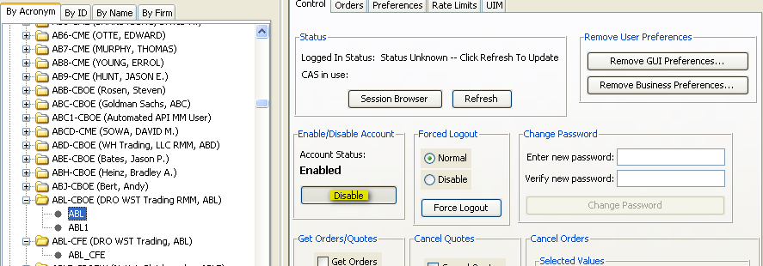

- Save your changes and disable user ABL1.
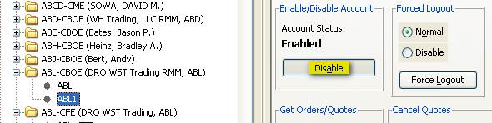

- Once again, save your changes in SA GUI.
- Next, login to the server where the global GC is running (i.e. atgqagc1).
- Type the following command without quotes to login to SQL
‘loginDb GLOBAL’
- At the SQL> prompt, run the following query (changing ABL to the user you are testing in this scenario).
‘select userid,acr,active from sbt_user where acr = 'ABL';’
- Verify that the user is still active by finding the ‘1’ in the 3rd column.
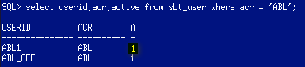

Test Case 2: Enable all users under Acronym
- Login to SA GUI.
- Select user ABL and ‘Enable’ this user.
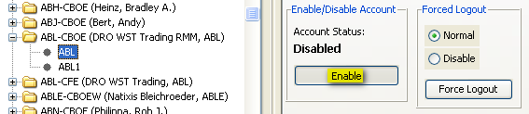

- Save your changes and enable user ABL1.
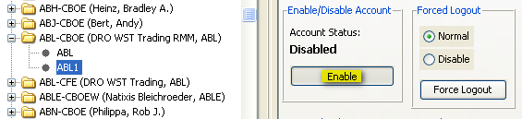
- Once again, save your changes in SA GUI.
- Next, login to the server where the global GC is running (i.e. atgqagc1).
- Type the following command without quotes to login to SQL
‘loginDb GLOBAL’
- At the SQL> prompt, run the following query (changing ABL to the user you are testing in this scenario).
‘select userid,acr,active from sbt_user where acr = 'ABL';’
- Verify that the user is still active by finding the ‘1’ in the 3rd column.

